**Generation of Bivariate Gaussian Random Samples**

**and Estimation of Statistical Parameters**

**김지영**



- MATLAB Code

clear; clf;

mx=3; sx=sqrt(2); my=-2; sy=1; rho=0.9;

N=1000;

xy=fn_Bivariate_Gauss(mx, my, sx, sy, rho, N);

for i=1:N

plot(xy(i,1), xy(i,2), '.'); hold on;

end

axis ([-10 10 -6 6]); grid on;

function xy=fn_Bivariate_Gauss(mx, my, sx, sy, rho, N)

x=gaussrv(mx, sx, N);

tilde_my=my+rho*(sy/sx)*(x-mx);

tilde_sy=sqrt((sy^2)*(1-rho^2));

y=gaussrv(tilde_my, tilde_sy, N);

xy=[x y];

end

function x=gaussrv(mu,sigma,m)

x=mu +(sigma*randn(m,1));

end

- Figure

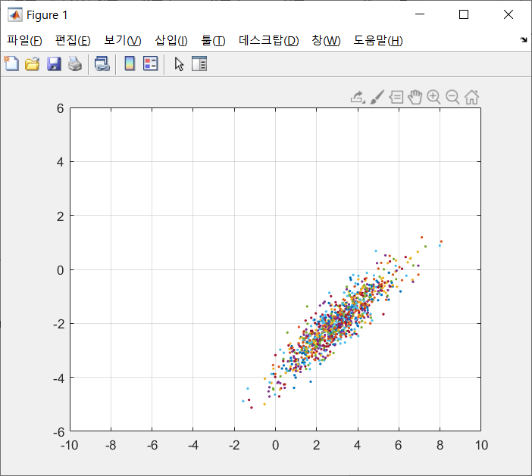



- MATLAB Code

clear; clf;

mx=3; sx=sqrt(2); my=-2; sy=1; rho=0.9;

N=1000;

x=gaussrv(mx, sx, N);

y=gaussrv(my, sy, N);

x_marginalpdf=gausspdf(mx, sx, x);

y_marginalpdf=gausspdf(my, sy, y);

subplot(121), hold on, histogram(x, 'Normalization', 'pdf');

subplot(122), hold on, histogram(y, 'Normalization', 'pdf');

x_pdf=floor(mx-4*sx):0.01:ceil(mx+4*sx);

y_pdf=floor(my-4*sx):0.01:ceil(mx+4*sy);

subplot(121), plot(x_pdf, gausspdf(mx, sx, x_pdf), '-r', 'LineWidth', 2);

subplot(122), plot(y_pdf, gausspdf(my, sy, y_pdf), '-r', 'LineWidth', 2);

function f=gausspdf(mu,sigma,x)

f=exp(-(x-mu).^2/(2*sigma^2))/...

sqrt(2*pi*sigma^2);

end

- Figure

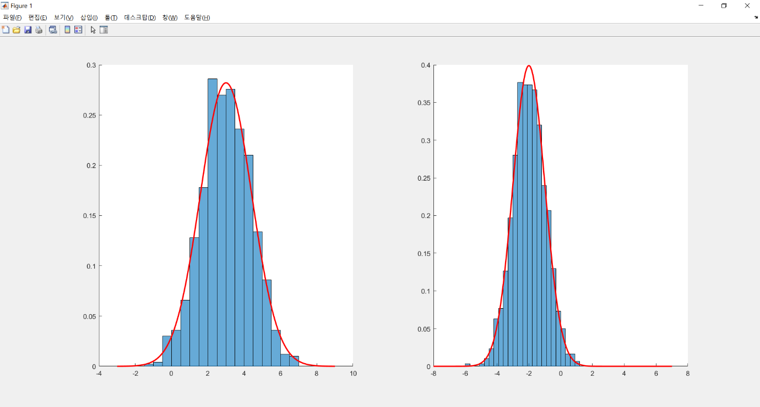=> x, y 각각 히스토그램과 실제 한계 pdf분포가 비슷하게 나옴을 확인할 수 있습니다.

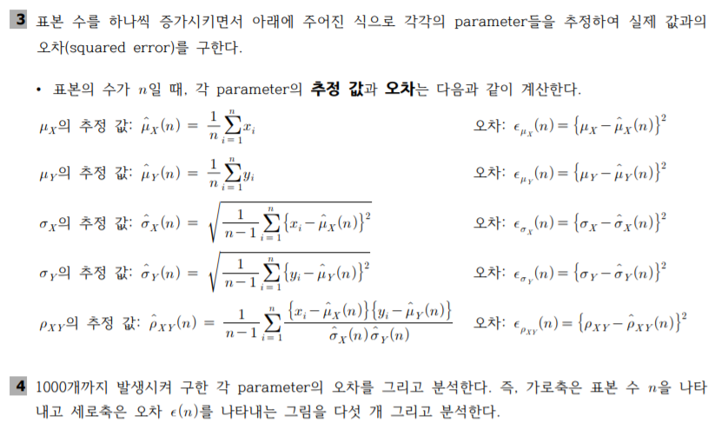

- MATLAB Code

clear; clf;

mx=3; sx=sqrt(2); my=-2; sy=1; rho=0.9;

n=1000;

x=gaussrv(mx, sx, n);

y=gaussrv(my, sy, n);

%--- mx추정

sum1=0;

for i=1:n

sum1=x(i,1)+sum1;

mx_hat(i)=sum1./i;

error_mx(i)=(mx-mx_hat(i)).^2;

end

%--- my추정

sum2=0;

for i=1:n

sum2=y(i,1)+sum2;

my_hat(i)=sum2./i;

error_my(i)=(mx-mx_hat(i)).^2;

end

%--- sigma x추정

sum3=0;

for i=2:n

sum3=(x(i,1)-mx_hat(i)).^2+sum3;

sx_hat(i)=sqrt((1/(i-1)).*sum3);

error_sx(i)=(sx-sx_hat(i)).^2;

end

%--- sigma y추정

sum4=0;

for i=2:n

sum4=(y(i,1)-mx_hat(i)).^2+sum4;

sy_hat(i)=sqrt((1/(i-1)).*sum4);

error_sy(i)=(sy-sy_hat(i)).^2;

end

%--- rho xy추정

sum5=0;

for i=2:n

sum5=((x(i,1)-mx_hat(i))).*((y(i,1)-my_hat(i)))./(sx_hat(i).*sy_hat(i))+sum5;

rho_hat(i)=(1/(i-1)).*sum5;

error_rho(i)=(rho-rho_hat(i)).^2;

end

N=1:n;

figure(1), plot(N, error_mx(N), 'r'); title('mx추정'); hold on; grid on;

figure(2), plot(N, error_my(N), 'r'); title('my추정'); hold on; grid on;

figure(3), plot(N, error_sx(N), 'r'); title('sigma x추정'); hold on; grid on;

figure(4), plot(N, error_sy(N), 'r'); title('sigma y추정'); hold on; grid on;

figure(5), plot(N, error_rho(N), 'r'); title('rho xy추정'); hold on; grid on;

- Figure

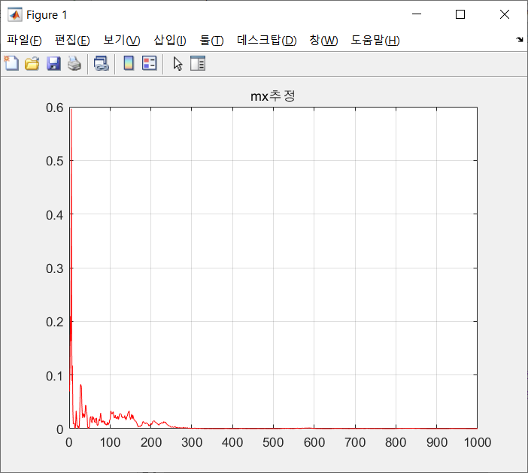

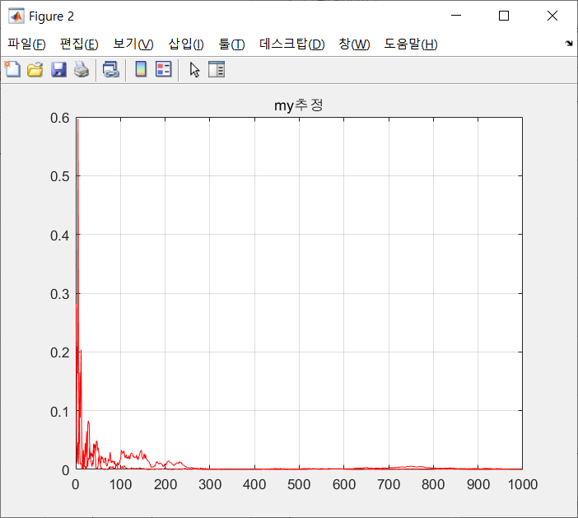

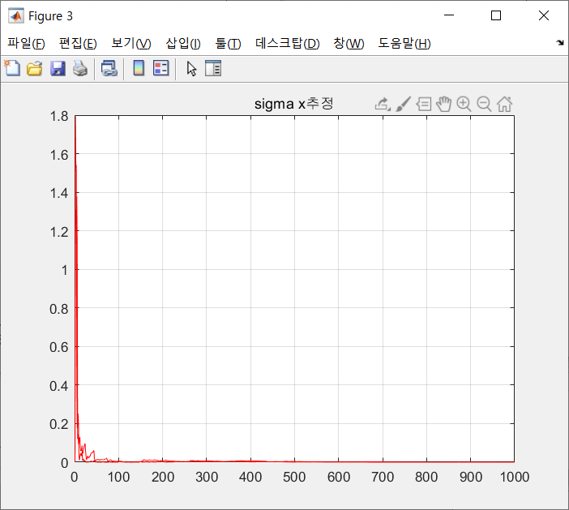

=> mx, my, sigma x를 추정한 결과, 표본 수가 증가할 수록 오차가 줄어들다 못해 거의 없습니다.

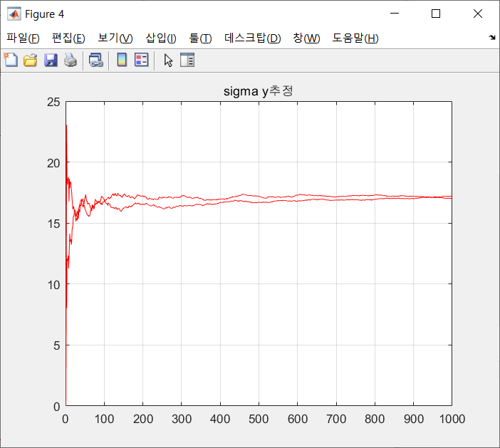

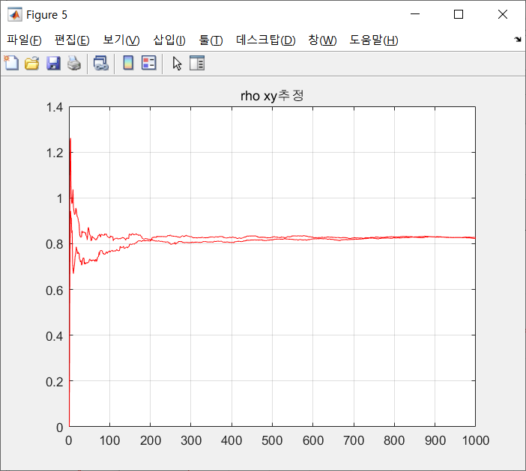

=> 반면, sigma y와 rho xy를 추정한 결과, 표본 수가 증가해도 특정 오차값이 계속 유지되며 변함이 없습니다.

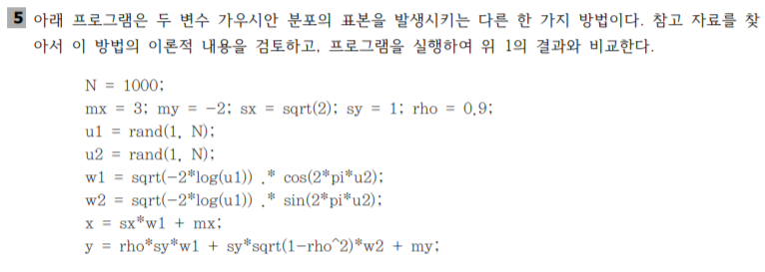

subplot(121), hold on, histogram(x, 'Normalization', 'pdf');

subplot(122), hold on, histogram(y, 'Normalization', 'pdf');

- Figure

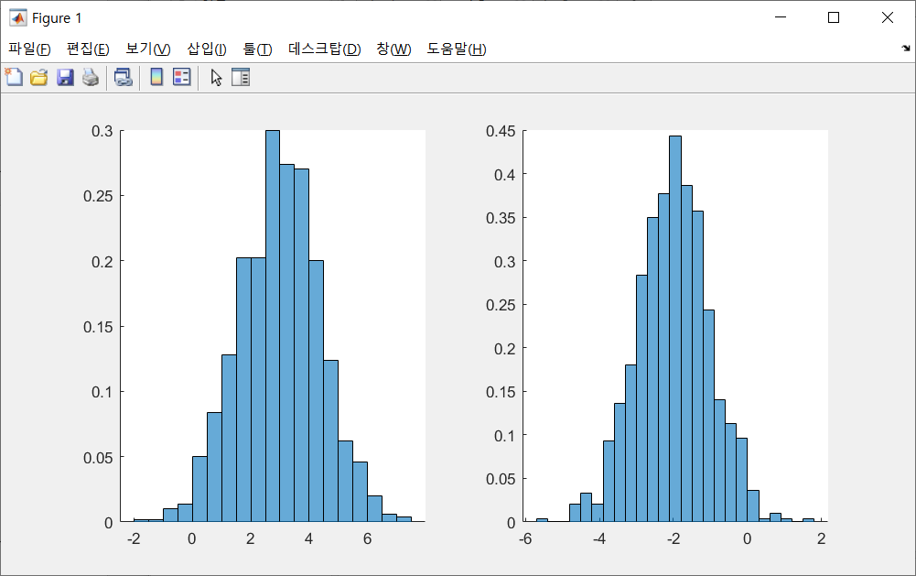

=> 문제2의 결과와 비슷하게 나온 모습을 확인할 수 있습니다.